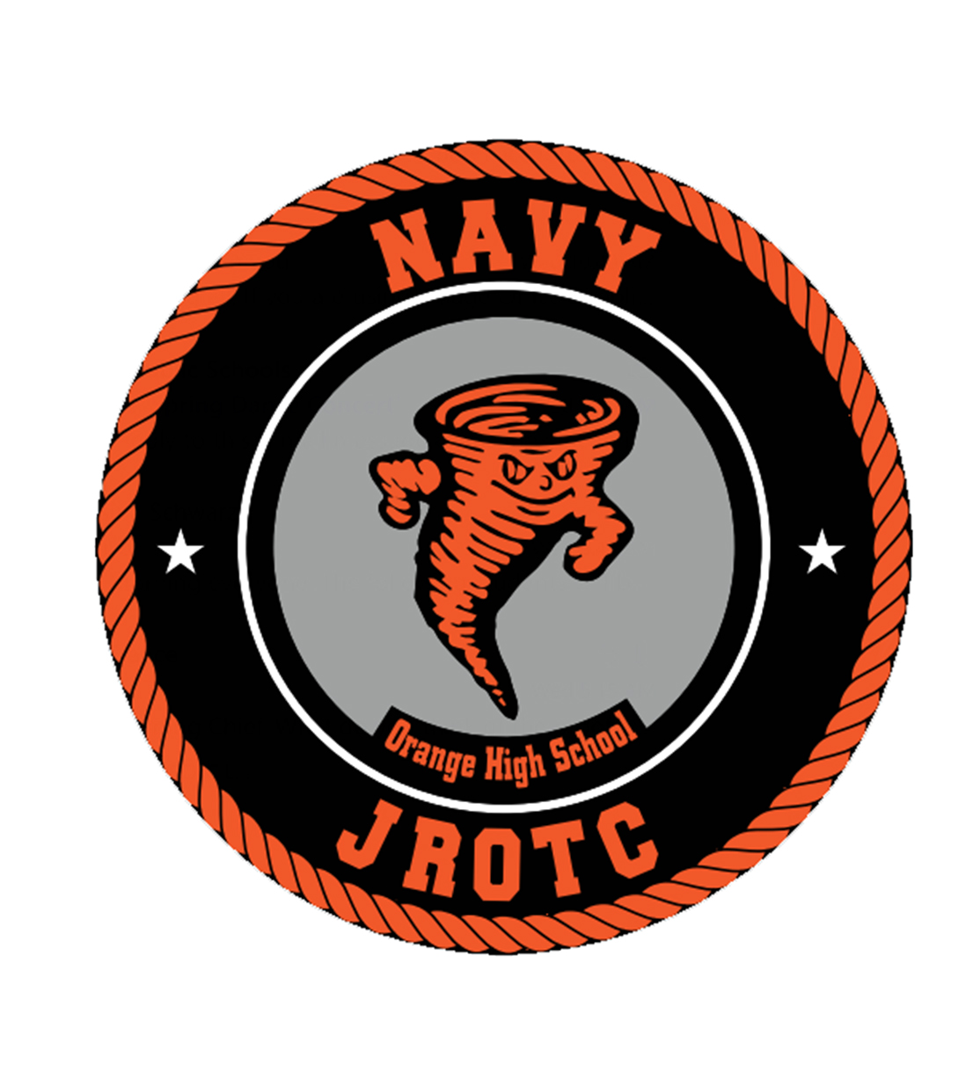
Honor, Courage, Commitment

Welcome Aboard!

My name is Chief Tom Sperduto and I am your Navy Junior Reserve Officer Training Corps (NJROTC) instructor at Orange High School. This letter is to welcome you to our program.

It takes a courageous student to step up and embrace the commitment of being a cadet at Orange High School. You were selected based on your desire to better yourself, school, and community.

NJROTC is your program. It will help you develop your natural gifts and personal character.
It offers tremendous opportunities for personal growth and future planning. The majority of our graduated cadets are now attending college and have earned millions of dollars in scholarships.

This year begins with challenges that are impossible to overcome alone. Together, we can overcome these challenges. Your leadership cadets are ready and excited to help YOU be successful. NJROTC is a family of cadets who respect each other and are committed to see each other succeed and meet their goals and dreams.

You will hear me repeat these words often as your Naval Science Instructor (NSI).
“I work for you.” I expect and look forward to helping you overcome challenges, and obstacles that you will face. I am honored for that opportunity. When you achieve your goals. I have achieved my own.

Our Core Values in NJROTC are Honor, Courage and Commitment. Those words will soon have a special meaning for you as you earn the title cadet. We are excited to have you onboard.

Respectfully,
Thomas J. Sperduto
Chief Tom Sperduto (USCG ret.)
Instructor
Orange High School NJROTC
sperduth@orange.k12.nj.us

